**Table of Content**

**Acknowledgement**

**System Planning**

1. **Introduction**

Founded in 2012, LiveTee is a multinational clothing-retail company that based in Malaysia. It is known as one of the fastest growing online clothing retailer in Malaysia. It sells fashion clothing for men, women as well as children. LiveTee is always trying to localize its products to fit the demands of customer by determining the current fashion trends in Malaysia. In order to attract more customers, LiveTee have been using famous cartoon characters, such as Disney characters (with permission), on their clothing. The clothing are sold in concept store based in Penang as well as e-commerce website. LiveTee has about 100 of workers and it produces thousands of clothing per day.

1. **Brief Description of the Current System**

Current cloth selling system is an online shopping website that sells clothing that suits everyone. Users have to register for an account and login to it in order to add items to cart and proceed to payment. Users are able to select size and quantity for each product. Admin and staffs are able to add new products, delete products as well as edit information of each product. Online banking to the bank account stated on the webpage is needed to place an order.

1. **Problems and Limitation of the Current System**

* Admin and staff are not able to manage and restock stock
* Admin and staff are not able to checkout using payment system such as PayPal
* Customers are not able to make reviews after purchasing the item
* Admin and staff are not able to view sales report
* Admin is not able to add and manage new staff

1. Objectives of the Proposed system

* Enable customer to view and purchase clothing of our company online
* Manage stock and sales efficiently
* Get reviews and feedback from customers
* Reach more consumers from Malaysia
* Save cost for physical store operation

1. **Project Scope Definition**

|  |  |
| --- | --- |
| **Modules** | **Description** |
| User Account Management | Customer registration  Edit profile information  Admin and staff registration  View profile |
| Products (Cloths) | View products with search filters  Add products  View existing products  Restock products  View available stocks  Delete products  Edit products information |
| Purchase | Add item to cart  View cart items  Remove item from cart  Edit quantity or size in cart  Make payment  View purchase history  Admin manage orders from customers  Admin view sales history |
| Report | Admin is able to view sales using graphs  Admin is able to select type of graphs  Admin is able to select the range of sales report |
| Review and rating | User provide review and rating  Visitors view review and rating |

1. **Hardware and Software selection**

*Hardware*:

Personal computer.

*Software*:

Programming language: HTML, CSS, JavaScript and PHP.

DBMS: phpMyAdmin

Documentation: Microsoft Office

**System Analysis and Design**

1. **Use Case Diagram**

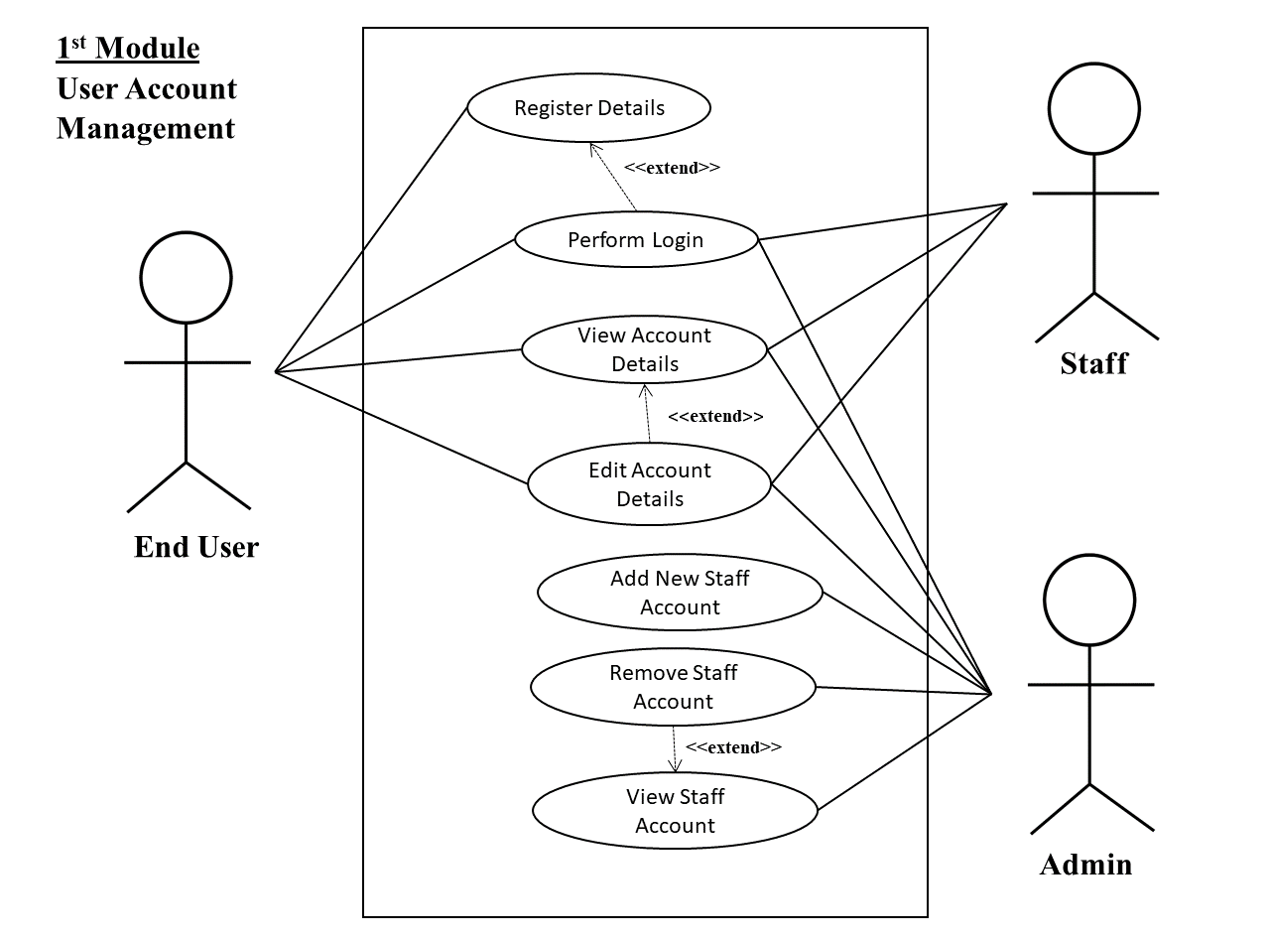

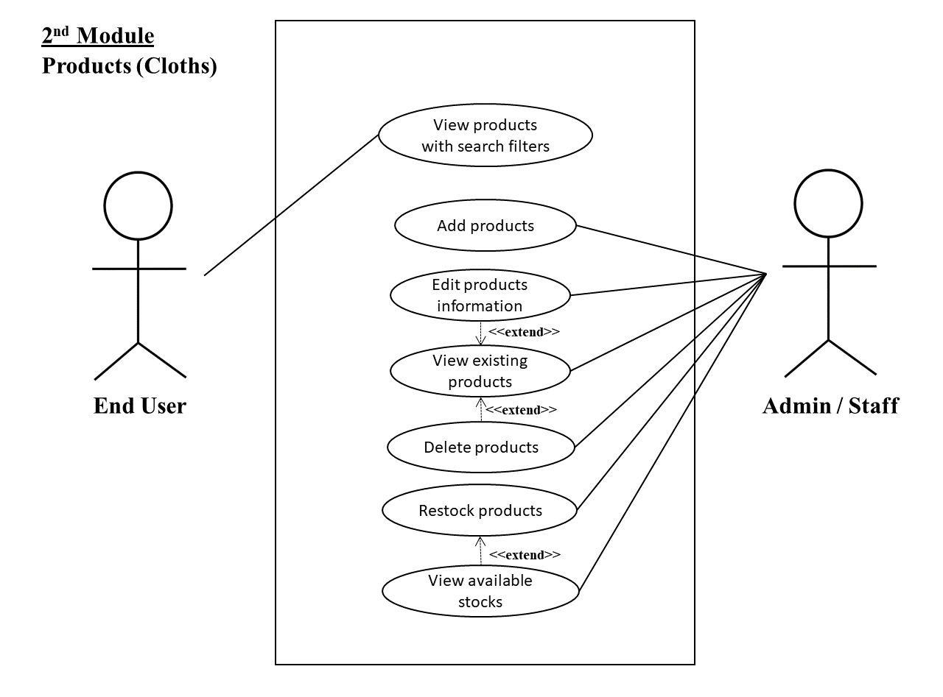

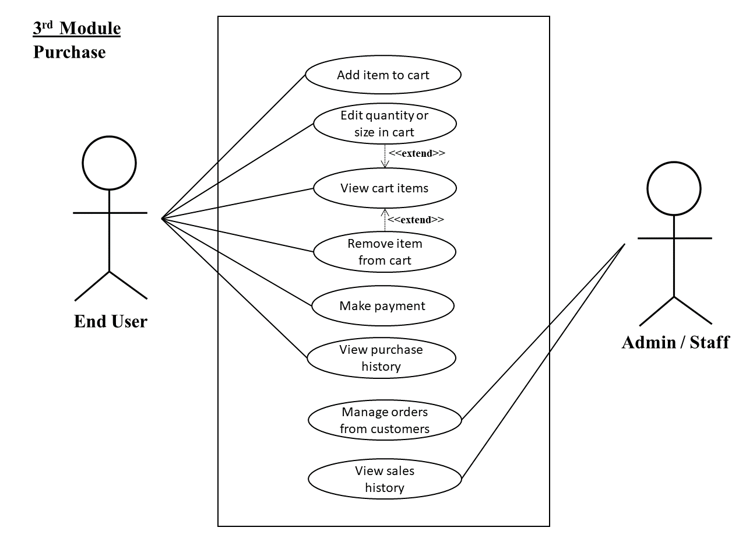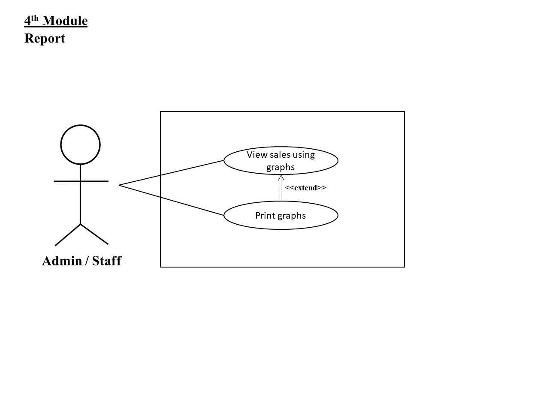

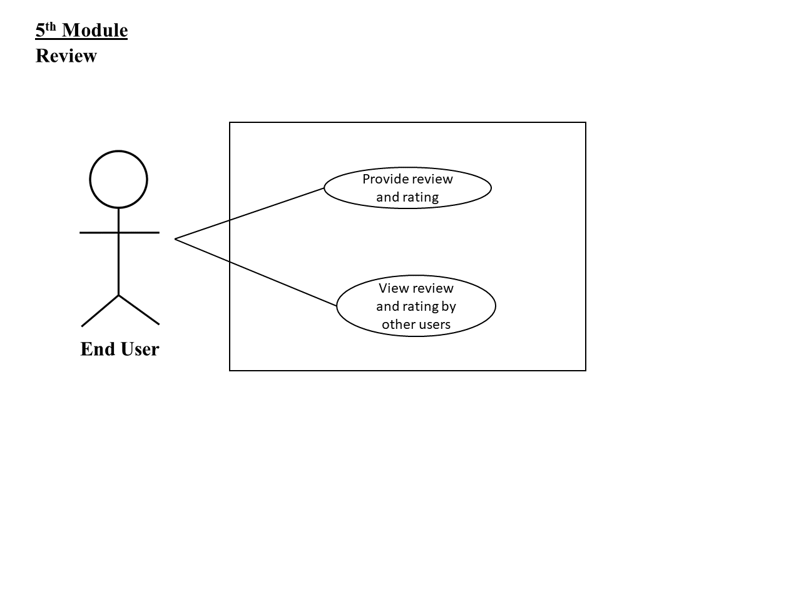

1. 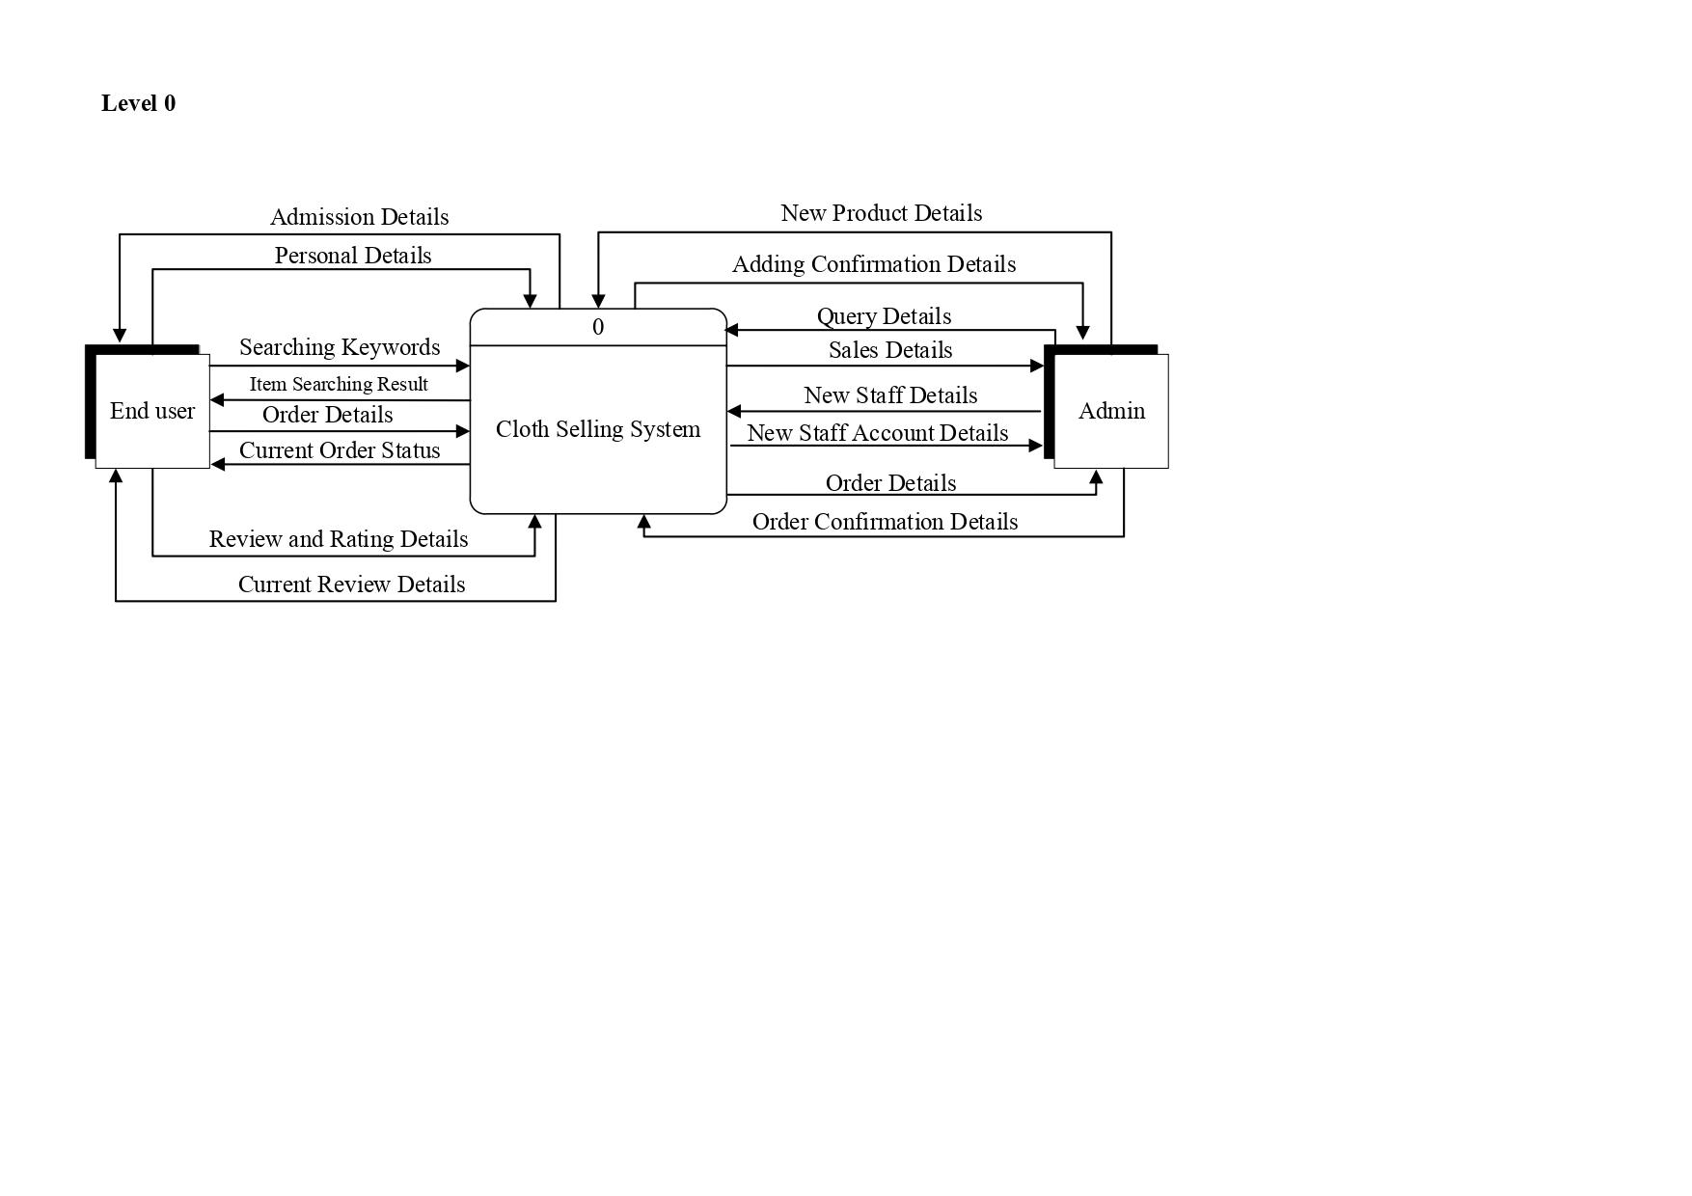**Data Flow Diagram**

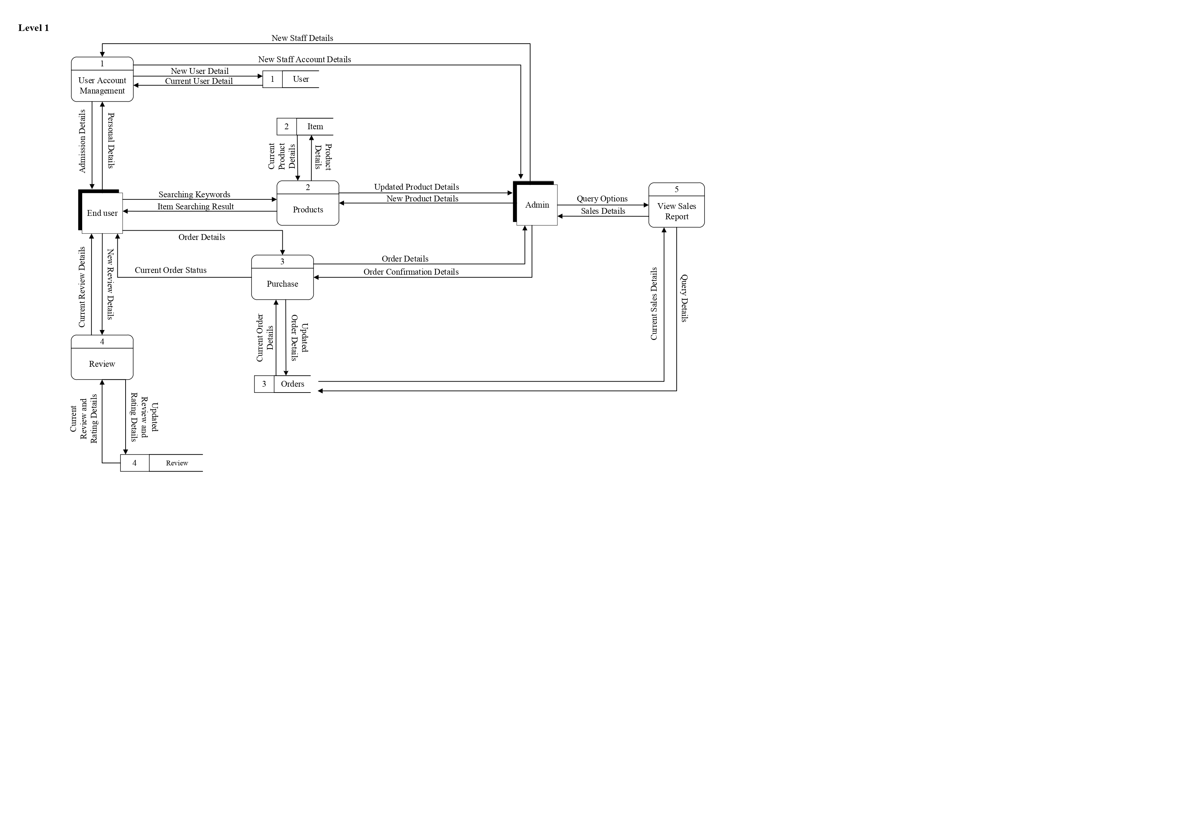

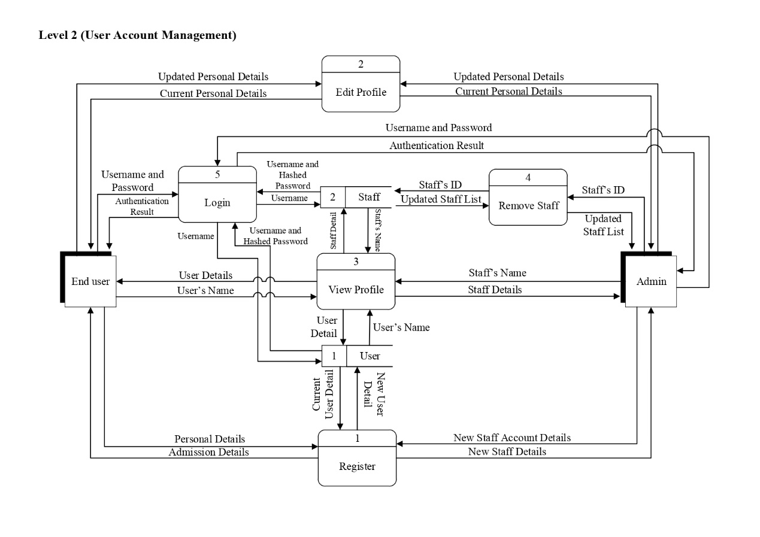

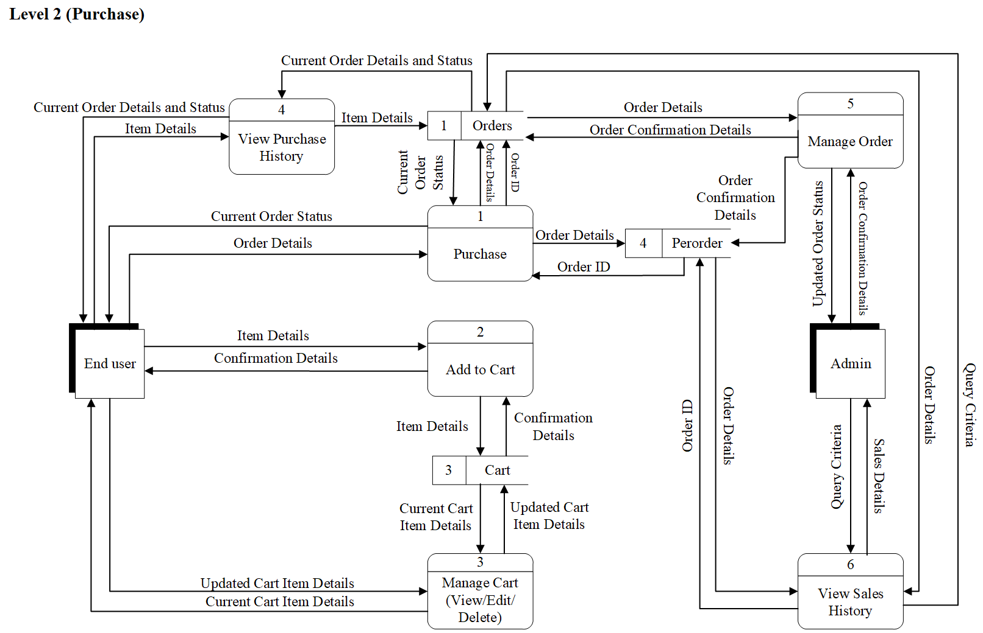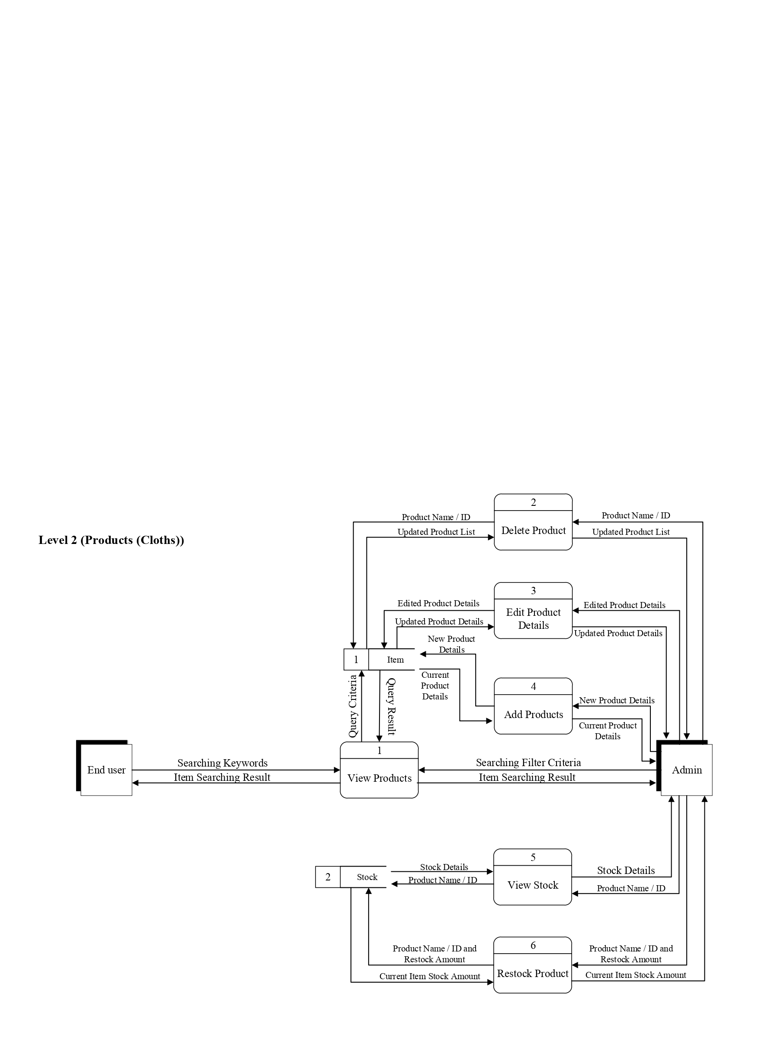

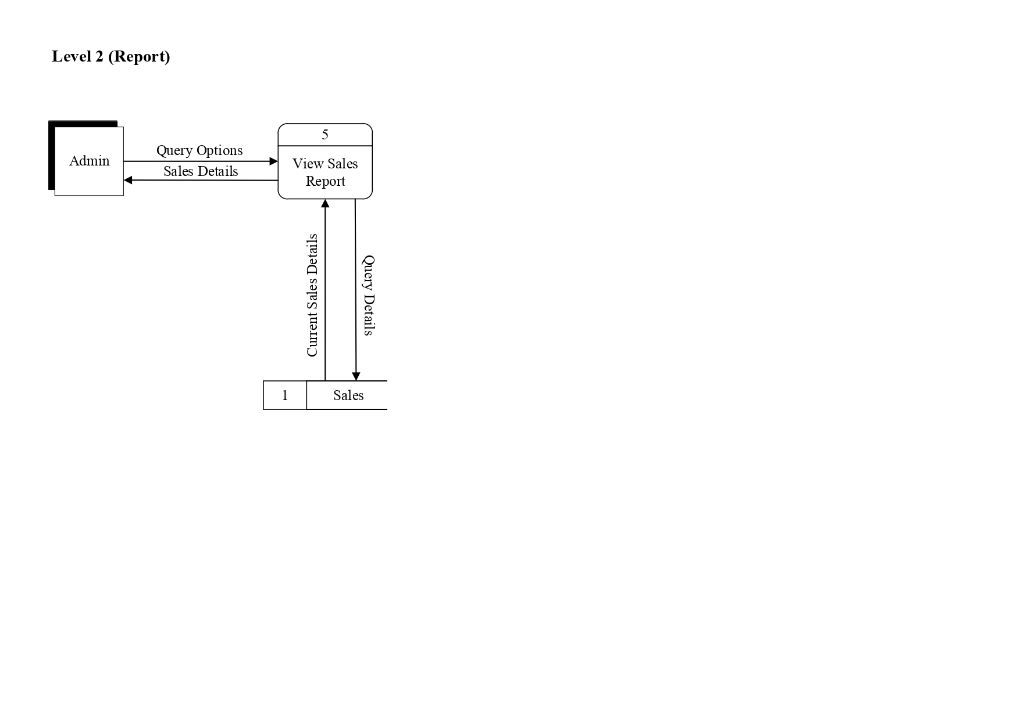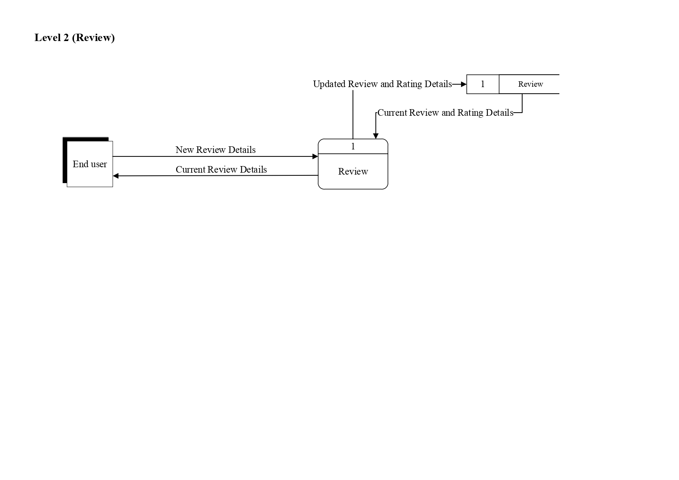

1. 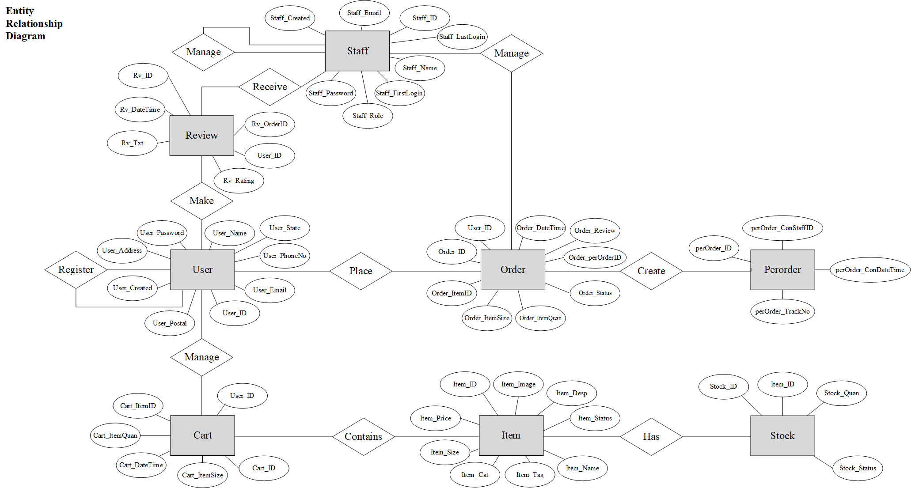**Entity Relationship Diagram**
2. **Data Design**
3. Staff

|  |  |  |  |
| --- | --- | --- | --- |
| Field Name | Type | Contraint Type | Description |
| Staff_ID | int(11) | Primary Key, AUTO_INCREMENT | Unique ID of every staff |
| Staff_Email | varchar(100) | Primary Key | Staff’s email |
| Staff_Name | varchar(100) |  | Staff’s name |
| Staff_FirstLogin | boolean |  | Determine first login of user and ask them to change a new password |
| Staff_Password | varchar(20) |  | Staff’s hashed password |
| Staff_Role | char(1) |  | Role as staff or admin |
| Staff_LastLogin | timestamp |  | Date and time where staff last login |
| Staff_Created | timestamp |  | Date and time where staff account is created |

1. User

|  |  |  |  |
| --- | --- | --- | --- |
| Field Name | Type | Contraint Type | Description |
| User_ID | int(11) | Primary Key, AUTO_INCREMENT | Unique ID of every user |
| User_Name | varchar(100) |  | User’s name |
| User_Email | varchar(100) | Primary Key | User’s email |
| User_Password | varchar(20) |  | User’s hashed password |
| User_PhoneNo | varchar(20) |  | User’s phone number |
| User_Address | text |  | User’s Birthday |
| User_Created | timestamp |  | Date and time where user account is created |
| User_Postal | varchar(10) |  | User’s postal code for delivery purpose |
| User_State | varchar(20) |  | User’s state for delivery purpose |

1. Item

|  |  |  |  |
| --- | --- | --- | --- |
| Field Name | Type | Contraint Type | Description |
| Item_ID | int(11) | Primary Key, AUTO_INCREMENT | Unique ID of every item |
| Item_Name | varchar(255) | Primary Key | Item’s name |
| Item_Price | decimal(7,2) |  | Item’s price |
| Item_Desp | text |  | Item’s description |
| Item_Size | varchar(50) |  | Item’s size |
| Item_Cat | varchar(20) |  | Item’s category |
| Item_Image | blob |  | Item’s preview image |
| Item_Tag | varchar(20) |  | Item’s tag such as “Sales” or “New” |
| Item_Status | tinyint(1) |  | Item’s status, whether it is available for sale or not |

1. Stock

|  |  |  |  |
| --- | --- | --- | --- |
| Field Name | Type | Contraint Type | Description |
| Stock_ID | int(11) | Primary Key, AUTO_INCREMENT | Unique ID of every stock |
| Item_ID | int(11) |  | Item’s ID which the stock belongs to |
| Item_Size | varchar(11) |  | Item’s size |
| Stock_Quan | int(11) |  | Stock’s quantity been added |

1. Orders

|  |  |  |  |
| --- | --- | --- | --- |
| Field Name | Type | Contraint Type | Description |
| Order_ID | int(11) | Primary Key, AUTO_INCREMENT | Unique ID of every order |
| User_ID | int(11) |  | User’s ID which the order belongs to |
| Order_ItemID | int(11) |  | Item’s ID in current order |
| Order_ItemSize | varchar(5) |  | Item’s size in current order |
| Order_ItemQuan | int(11) |  | Item’s quantity in current order |
| Order_Status | varchar(20) |  | Whether the order is still processing, delivering or received |
| Order_Review | tinyint(1) |  | Check if current order has written its review |
| Order_DateTime | timestamp |  | Date and time when the order is placed |
| Order_perOrderID | int(11) |  |  |

1. Perorder

|  |  |  |  |
| --- | --- | --- | --- |
| Field Name | Type | Contraint Type | Description |
| perOrder_ID | int(11) | Primary Key, AUTO_INCREMENT | Unique ID for every orders group |
| perOrder_ConStaffID | varchar(11) |  | Staff’s ID of staff that confirm the order |
| perOrder_ConDateTime | timestamp |  | Date and time when order is confirmed |
| perOrder_TrackNo | varchar(100) |  | Tracking number for delivered items |

1. Cart

|  |  |  |  |
| --- | --- | --- | --- |
| Field Name | Type | Contraint Type | Description |
| Cart_ID | int(11) | Primary Key, AUTO_INCREMENT | Unique ID of every cart of users |
| User_ID | int(11) |  | User’s ID which the cart belongs to |
| Cart_ItemID | int(11) |  | Item’s ID in current cart |
| Cart_ItemQuan | int(11) |  | Item’s quantity in current cart |
| Cart_ItemSize | varchar(5) |  | Item’s size in current cart |
| Cart_DateTime | timestamp |  | Date and time when the item is added to cart |

1. Review

|  |  |  |  |
| --- | --- | --- | --- |
| Field Name | Type | Contraint Type | Description |
| Rv_ID | text | Primary Key, AUTO_INCREMENT | Unique ID of every review and rating |
| Rv_OrderID | int(11) | Primary Key | Item’s ID which the review and rating belongs to |
| User_ID | int(11) |  | User’s ID which the review and rating belongs to |
| Rv_Txt | text |  | Review text from user |
| Rv_Rating | char(1) |  | Rating by user from 1 star to 5 stars |
| Rv_DateTime | timestamp |  | Date and time when the rating and review is submitted |
| Rv_AprvStatus | varchar(20) |  | Approval status of review and rating |

1. **Interface Design (Balsamiq)**
2. **Interface Design (Actual System)**

**Literature Review**

***The Effect of Perceived Risk on Online Shopping in Jordan***

Online shopping may have perceived risks, such as consumers are not able to ensure the quality of the product directly and the security of payment through online (Salo and Karjaluoto, 2007; Zhou et al., 2008). Consumers have to rely and trust on the product information and image shown online to examine the quality of product (Jarvenpaa and Tractinsky, 1999). Time risks during purchasing online including slow delivery time and difficulty on placing orders (Forsythe et al., 2006). Consumers have to worry that the goods will be damaged during delivery due to improper packaging or handling of goods (Claudia, 2012). Consumers are concern about the security risk of using credits cards and revealing personal information online (Pallab, 1996). Consumers will avoid websites that require them to provide personal information for registration (Kayworth and Whitten, 2010).

***Literature derived reference models for the adoption of online shopping***

Perceived risk on online shopping, such as credit cards problem and receiving wrong items, will negatively affect consumers’ shopping intention (A. Bhatnagar, S. Misra, H.R. Rao, 2000). Website accessibility will influence the shopping intention of consumers (H. Li, C. Kuo, M.G. Russell, 1999). Trust issue also became a major problem in adoption of online shopping (B. Friedman, P.H. Kahn, D.C. Howe ,2000). The higher of trustfulness, the higher the shopping intention of consumers (A.M. Chircu, G.B. Davis, R.J. Kauffman, 2000). The knowledge of using computer and online shopping of consumers are positively related to online shopping adoption (C.V. Slyke, 2002). Hence, consumers with higher understanding in technology and its operation process will lead to higher rate of online shopping. Online selling system that managed and operated by acknowledged companies will have higher competitive advantage over other companies (K. McKinsey, 2001).

***What Makes Consumers Buy from Internet? A Longitudinal Study of Online Shopping***

Discounts, coupons or other offers should be given to consumers in order to attract them to shop online (Gehrke and Turban, 1999). Customers’ confidence on the online shopping system can be increased by using keywords such as “Secure Server” (Gehrke and Turban, 1999). Checkout process should not be too complicated as customers will get frustrated (Lohse and Spiller, 1998). Guarantees and warranties should be offered to customers so that the customer service can be improved (Dholakia and Rego, 1998). In order to reach higher sales, Frequently Asked Question (FAQ) about the company and its products should be implemented (Lohse and Spiller, 1988). Showing certain benefit of a product is able to increase the quality of content on online shopping system (Dholakia and Rego, 1998).

***An empirical analysis of online shopping adoption in Beijing, China***

A website with poor design makes consumers not to shop online (Shergill and Chen, 2005). Security and privacy features are able to attract consumers to shop online (Suki, 2007). Poor service quality in e-commerce will negatively affect the decision of consumers to purchase online (Vijayasarathy and Jones, 2000). A good price is able to attract consumers to purchase online (Ahuja et al., 2003). The main reason of why consumers shop online is because the wide variety of products (Szymanski and Hise, 2000). Lack of product guarantee will prevent consumer to buy goods online, especially for product with high price (Koyuncu and Bhattacharya, 2004). Koyuncu and Bhattacharya (2004) also stated that consumers would lower the rate of purchasing online if they do not receive the item within guaranteed time.

***Factors influencing consumers’ online shopping in China***

Most of the consumers that shop online are male as it involve using computer (Dholakis and Chiang, 2003). The higher the education level of consumers, the higher their exposure to internet technology as they have more confidence (Hui and Wan, 2007). Consumers that shop online tend to have higher income compared to traditional store shoppers (Mahmood et al., 2004). The number of children of married Chinese can be used to predict their shopping intention on clothing (Kim and Kim, 2004). The consumers will only choose to shop online on a channel if they are confident with that channel and the perceived risk in low (Black et al., 2002). As the internet availability is getting higher and higher nowadays, more Chinese consumers tend to use the internet for information, communication and entertainment purpose (Gong et al., 2013).

**System Development and Implementation**

1. **Functional Requirement**

**Module Name:** User Account Management

* Customer is able to register an new account
* Able to edit profile information
* Admin is able to register an new account for admin or staff
* Able to view profile

**Module Name:** Products (Cloths)

* Able to view products with search filters
* Able to add products
* Able to view existing products
* Able to restock products
* Able to view available stocks
* Able to delete products
* Able to edit products information

**Module Name:** Purchase

* Able to add item to cart
* Able to view cart items
* Able to remove item from cart
* Able to edit quantity or size in cart
* Able to make payment
* Able to view purchase history
* Admin is able to manage orders from customers
* Admin is able to view sales history

**Module Name:** Report

* Admin is able to view sales using graphs
* Admin is able to select type of graphs
* Admin is able to select the range of sales report

**Module Name:** Review and rating

* User is able to provide review and rating
* Visitors are able to view review and rating

1. **Conversion Plan**

**Phased**

Phased conversion means replacing the current system with new one in phases until the current system is fully replaced by new system. New system is broken down by smaller modules and replace corresponding modules in current system. The reason of choosing this conversion plan is that it allows the users to get familiar with the system gradually. Users do not need to worry about using the complete new system without any prior knowledge as they can be trained stage by stage. By doing this, mistakes made by user can be decreased as well. Besides, phased conversion allows developers to detect and resolve the errors and bugs without a lot of down time. The new system will be tested modules by modules, which mean resolution of an error is focused on a module and hence time needed for debugging will be shorten. Although using phased conversion will require much of time for complete implementation of new system, but the risk of getting system catastrophe is able to decrease.

**Program Listing**

|  |  |
| --- | --- |
| **Modules** | **Pages Created** |
|  |  |
|  |  |
|  |  |
|  |  |
|  |  |
|  |  |
|  |  |

**System Testing and Maintenance**

1. **Test Plan and Test Case**

**Test Plan**

|  |  |
| --- | --- |
| **Test Case No.** | **Description** |
| 1.0 | To test the Add Clothing Button. Details of new clothing will be saved in database. |
| 2.0 | To test the Add Stock Button. New stock amount will be updated in database. |
| 3.0 | To test the Search Button for clothing. Clothing name or ID that match with the keyword entered by user will be displayed. |
| 4.0 | To test the Delete Button for clothing. Clothing will be deleted from database. |
| 5.0 | To test the Save Button for sales report. Sales report will be downloaded to local computer from database. |
| 6.0 | To test the Register Now Button on user page. Details entered by new user will be saved in database. |
| 7.0 | To test the Checkout Button on cart page. The webpage will be redirected to PayPal page to proceed with payment. |
| 8.0 | To test the Confirm Button on change password page. New password will be saved in database. |
| 9.0 | To test the Submit Review Button. Reviews and rating submitted by user will be displayed on respective product page. |
| 10.0 | To test the Add To Cart Button. Item selected by user along with the size and quantity will be inserted to database. |

**Test Case**

Module Name: Products (Cloths)

|  |  |
| --- | --- |
| **Test Case no.** | 1.0 |
| **Test Objective** | To test the Add Clothing Button. |
| **Test Data** | Add Button |
| **Expected result** | Details of new clothing will be saved in database. |
| **Actual result** | *Database* C:\Users\Wayne Ng\AppData\Local\Microsoft\Windows\INetCache\Content.MSO\2810E5DE.tmp |
| **Remark** | Successful |

Module Name: Products (Cloths)

|  |  |
| --- | --- |
| **Test Case no.** | 2.0 |
| **Test Objective** | To test the Add Stock Button. |
| **Test Data** | Add Button |
| **Expected result** | New stock amount will be updated in database. |
| **Actual result** | ***Before***  ***After*** |
| **Remark** | Successful |

Module Name: Products (Cloths)

|  |  |
| --- | --- |
| **Test Case no.** | 3.0 |
| **Test Objective** | To test the Search Button for clothing. |
| **Test Data** | Search Button |
| **Expected result** | Clothing name or ID that match with the keyword entered by user will be displayed. |
| **Actual result** |  |
| **Remark** | Successful |

Module Name: Products (Cloths)

|  |  |
| --- | --- |
| **Test Case no.** | 4.0 |
| **Test Objective** | To test the Delete Button for clothing. |
| **Test Data** | Delete Button |
| **Expected result** | Clothing will be deleted from database. |
| **Actual result** | ***Before***  ***After*** |
| **Remark** | Successful |

Module Name: Report

|  |  |
| --- | --- |
| **Test Case no.** | 5.0 |
| **Test Objective** | To test the Save Button for sales report. |
| **Test Data** | Download Button |
| **Expected result** | Sales report will be downloaded to local computer from database. |
| **Actual result** |  |
| **Remark** | Successful |

Module Name: User Account Management

|  |  |
| --- | --- |
| **Test Case no.** | 6.0 |
| **Test Objective** | To test the Register Now Button on user page. |
| **Test Data** | Register Button |
| **Expected result** | Details entered by new user will be saved in database. |
| **Actual result** | ***Database*** |
| **Remark** | Successful |

Module Name: Purchase

|  |  |
| --- | --- |
| **Test Case no.** | 7.0 |
| **Test Objective** | To test the Checkout Button on cart page. |
| **Test Data** | Checkout Button |
| **Expected result** | The webpage will be redirected to PayPal page to proceed with payment. |
| **Actual result** |  |
| **Remark** | Successful |

Module Name: User Account Management

|  |  |
| --- | --- |
| **Test Case no.** | 8.0 |
| **Test Objective** | To test the Confirm Button on change password page. |
| **Test Data** | Save Button |
| **Expected result** | New password will be saved in database. |
| **Actual result** | ***Old Password***  ***New Password*** |
| **Remark** | Successful |

Module Name: Review and Rating

|  |  |
| --- | --- |
| **Test Case no.** | 9.0 |
| **Test Objective** | To test the Submit Review Button. |
| **Test Data** | Submit Button |
| **Expected result** | Reviews and rating submitted by user will be displayed on respective product page. |
| **Actual result** |  |
| **Remark** | Successful |

Module Name: Review

|  |  |
| --- | --- |
| **Test Case no.** | 10.0 |
| **Test Objective** | To test the Add To Cart Button. |
| **Test Data** | Add Button |
| **Expected result** | Item selected by user along with the size and quantity will be inserted to database. |
| **Actual result** |  |
| **Remark** | Successful |

1. **Test Result**

|  |  |
| --- | --- |
| **Test Case No.** | **Remark** |
| 1.0 | Successful |
| 2.0 | Successful |
| 3.0 | Successful |
| 4.0 | Successful |
| 5.0 | Successful |
| 6.0 | Successful |
| 7.0 | Successful |
| 8.0 | Successful |
| 9.0 | Successful |
| 10.0 | Successful |

**Conclusions**

1. **Problems and Solutions**

During the development of the system, I found that each group of orders by user does not have a unique ID, which is important for costumers and admins to check back the orders. To resolve this problem, I have created a new table in database that store the order ID of each group of orders placed. While in table that contains all the orders details, a new column is added to store the order ID and the data in this column is linked with order ID in new table. By doing so, all the orders with same order ID can be group together.

Besides, the system requires a payment system but I do not have any knowledge of integrating PayPal or other payment method with the system. In order to develop the payment function, I have carried out researches on Internet. I watched several YouTube tutorials, reading documentations and seek solutions from forums. Besides, I have also seek advice from lecturers on how should I implement PayPal in my system. Eventually, I am able to integrate a working PayPal payment system with my system.

While developing the product page, I realised that the stock quantity of each clothing size should be displayed according to what users selected on the size option tag. However, I do not want the page refreshes every time users change the clothing size on the size option tag, as it will make visitors frustrated. This issue also happens on cart page when users want to edit the item’s details. In order to solve this, I have learnt how to user AJAX to run SQL queries and reload certain part of the webpage without refreshing the whole webpage.

1. **Critical Appraisal**

The strength of the new system is user can make payment using PayPal instead of transferring the money to owner’s bank account manually. By using PayPal, the system will place the orders automatically once the customer has made the payment, without the need of confirmation by the owner. Besides, the sales report generated can be in various form, such as pie graph, bar graph or line graph. Different type of graphs may be used for different purposes and ease the interpretation of results. User can also adjust the range of the sales report according to his or her own preference, such as sales for this month or sales for last month. Furthermore, the new system is using AJAX (Asynchronous JavaScript and XML) to enhance the user experience. For instance, user can edit the quantity or size of their items in shopping cart without refreshing the page after doing so. For the product page, the use of AJAX also enable the user to view the stock quantity of each size without page refreshing when selecting their preferred size.

For the weakness of the new system is the sales report can only display the amount of sales for each day but not the overall revenue earned on each day and sales on each product. Besides, users of the system are not able to upload their own profile picture to the system, which will cause difficulty of users in identifying each other. Furthermore, users are not able to sort the table by clicking on the headers. Only limited important field can be sorted. In addition, reviews submitted by customers will be posted on the product page directly instead of granting approval by admins. Without prior checking on the reviews, customers may submitted something that is nonsense or vulgar on the system. Finally, users are not provided with suggestions while entering keywords on search bar. Lacking of this function will cause users to perform inaccurate queries (spelling errors), which will also affect the result received.

For the future enhancements, the system should generated sales report in aspects of overall sales and revenue as well as sales and revenue of each item. By doing so, the trend of each item can be identified and the sales of each item can be used to determine what kind of business strategy should be implemented. Besides, the system should enable users to upload their profile picture. Furthermore, tables displayed on the system should be able to sort by clicking on the table headers. For example, clicking on ‘Name’ header should sort the names in ascending order (A to Z) and by clicking again the ‘Name’ header should sort the names in descending order (Z to A). In addition, the system should enable admins to check all of the reviews by the costumer before posting the review to the product page of the system. Finally, the system should provide users with suggestions while they are typing on the search bar.

**User Manual**

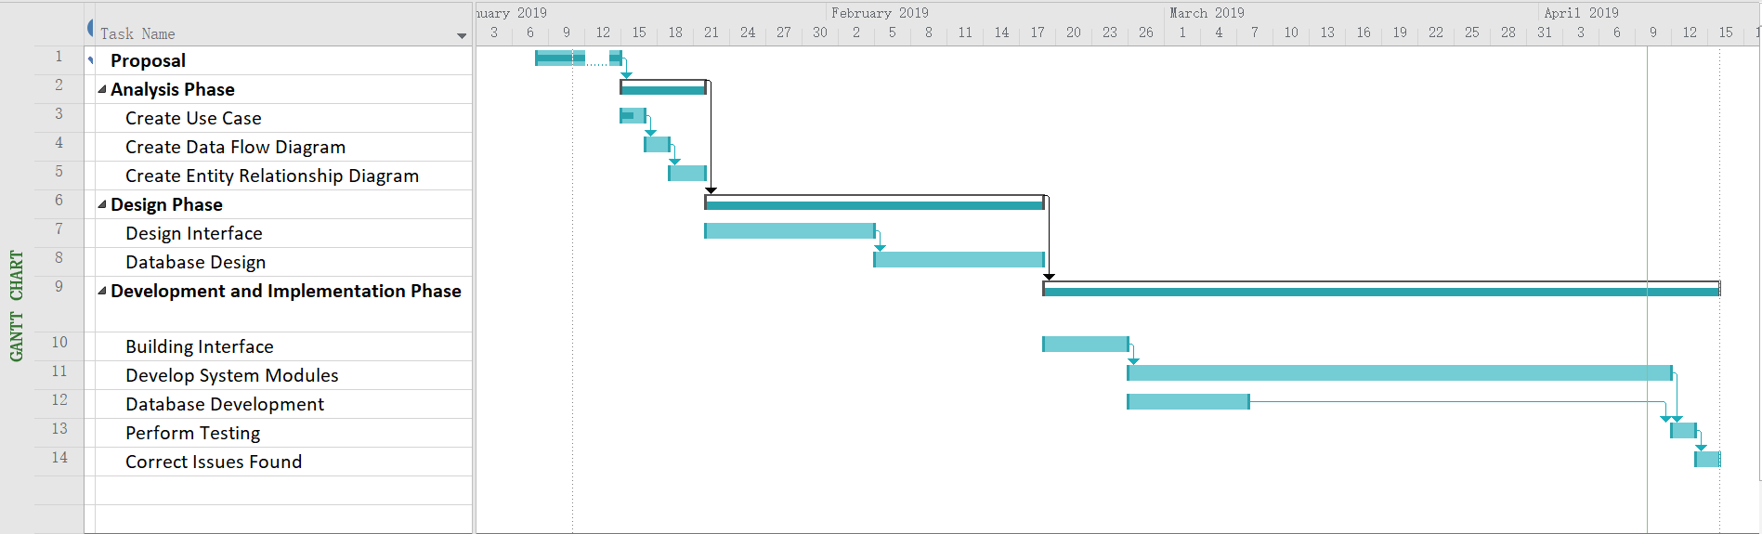**Gantt Chart**